FORNAX™ ePlanCheck Rule
Rule Information
Rule ID | WTR 6.4.20
Rule Name | Maximum Depth of Water Pipes below Ground
Chapter | 2 Distribution
Section | 2.4 Services
Handbook | Code of Practice for Water Services  Incorporating Amendment No. 1 and No .2

Rule Description
2.4 Services

2.4.20 Water pipes shall not be laid at a depth more than 2m below ground. Where unavoidable, due consideration should be given to the maintenance and repair of the pipe.

Rule Interpretation
- This rule checks the maximum depth for water pipes below ground (Figure 01).
- The maximum depth is 2000mm (2.00m), measured from bottom of the pipe to the top of the Finished Grade Line (FGL).
TOP OF SLAB
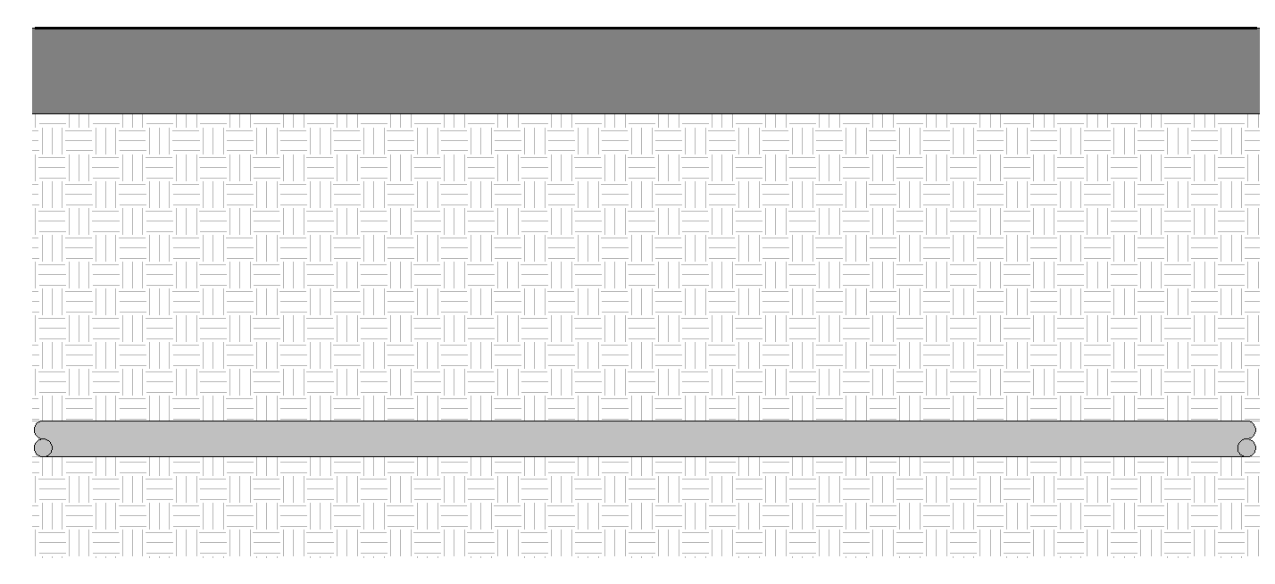
MAXIMUM DEPTH
= 2000mm

EARTH MATERIAL
WATER PIPE

MAXIMUM DEPTH OF WATER PIPES BELOW GROUND
FIGURE 01

Rule Scenario

Scenario 01 – Compliant 1
Requirement | Maximum depth of water pipes shall be 2000mm below FGL.
Description | Depth of water pipe is 2000mm below concrete FGL.
TOP OF SLAB
MAXIMUM DEPTH
= 2000mm

EARTH MATERIAL
WATER PIPE

SECTION
FIGURE SCENARIO

Scenario 02 – Compliant 1
Requirement | Maximum depth of water pipes shall be 2000mm below FGL.
Description | Depth of water pipe is 2000mm below ground.
TOP OF TOPSURFACE
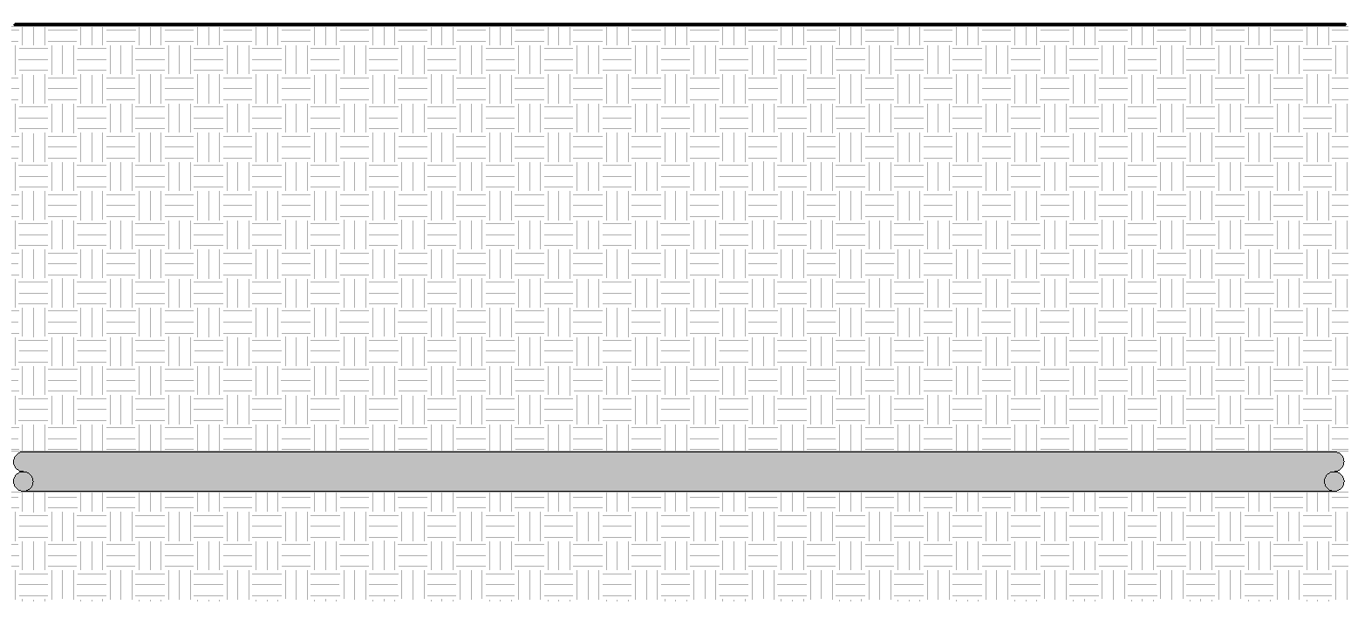
MAXIMUM DEPTH
= 2000mm

EARTH MATERIAL
WATER PIPE

SECTION
FIGURE SCENARIO

Urinal

Scenario 01 – Non-Compliant 1
Requirement | Maximum depth of water pipes shall be 2000mm below FGL.
Description | Depth of water pipe is 2100mm below concrete FGL.
TOP OF SLAB
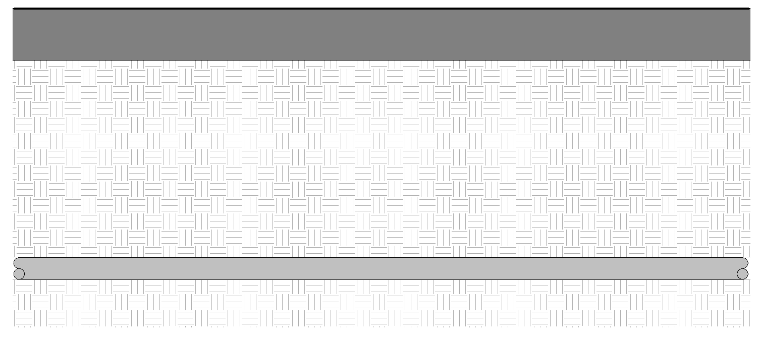
MAXIMUM DEPTH
= 2100mm

EARTH MATERIAL
WATER PIPE

SECTION
FIGURE SCENARIO

Scenario 02 – Non-Compliant 1
Requirement | Maximum depth of water pipes shall be 2000mm below FGL.
Description | Depth of water pipe is 2100mm below ground.
TOP OF TOPOSURFACE
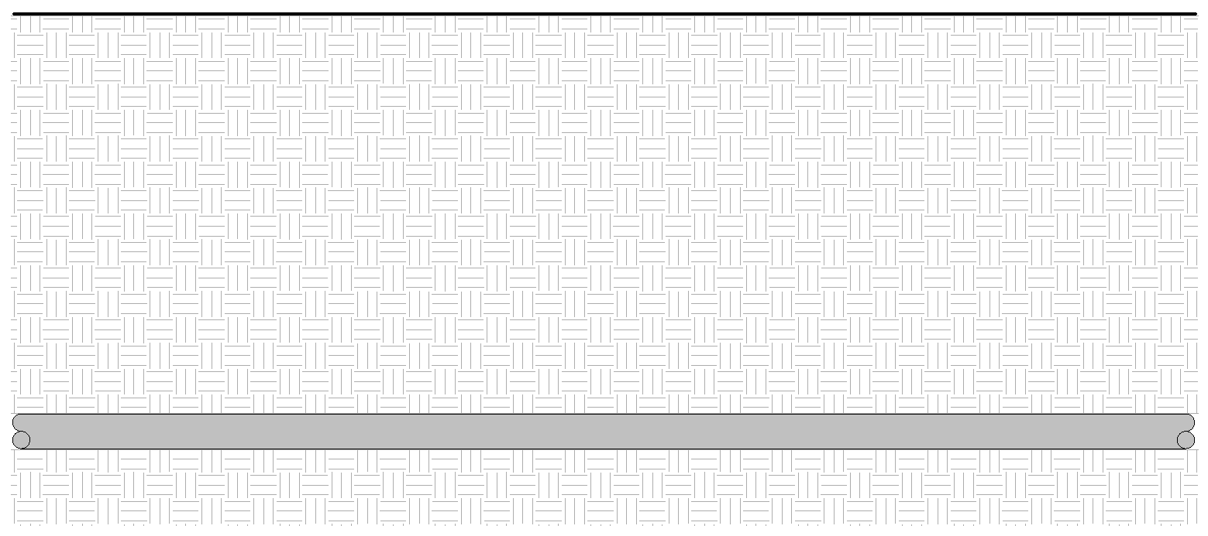
MAXIMUM DEPTH
= 2100mm

EARTH MATERIAL

SECTION
FIGURE SCENARIO

Urinal
WATER PIPE

Request For Information
- The Rule description stated in 24_Appendix 2_COP rules.pdf for WTR 6.4.20 does not exist in IBS_PUB-CP 48-2005+Amd 1&2.pdf

- We believe the Rule stated in 24_Appendix 2_COP rules.pdf actually directs to WTR 2.4.20 in IBS_PUB-CP 48-2005+Amd 1&2.pdf. Is this correct?

- Where do we reckon the measurement from the pipe, invert level or top?

Model PreCheck

Required Elements | Required Attributes
PipeSegment | Any
Slab | Any
Site | Site

Rule Parameters

System Type
Cold Water |  | 
Hot Water
 | Sanitary
 | Sewerage
Vent

Element Type 1
State | Type | Property | Operator | Value
Include | PipeSegment | Any | N.A. | N.A.
Exclude |  | Any | Match | N.A.
 |  |  | N.A. | <User define>

Element Type 2
State | Type | Property | Operator | Value
Include | Slab | Any | Contains | Any
Include | IfcSIte | Any | N.A. | N.A.
Exclude |  |  | Match | <User define>

Element type 1 Condition

*Maximum depth is | 2000 | mm from Element Type 2
*Should be below Element Type 2

*When detecting the FGL follow the path of the pipe and then project upwards. The nearest slab or the top of the topo should be the one detected.

Result Messages
- WTR 6.4.20 Maximum Depth of Water Pipes below Ground
  - Non-compliant (TotalResultNumeric)
    - BuildingStorey (TotalResultPerFloorNumeric)
      - ElementNameNumeric: Depth = TotalResultNumeric mm
  - Compliant (TotalResultNumeric)
    - BuildingStorey (TotalResultPerFloorNumeric)
      - ElementNameNumeric: Depth = TotalResultNumeric mm

Sample Result Messages
- WTR 6.4.20 Maximum Depth of Water Pipes below Ground
  - Non-compliant (2)
    - Level (1)
      - Water Pipe 101.2: Depth = 2100mm

2100mm

SECTION

      - Level (1)
      - Water Pipe 101.2: Depth = 2100mm

2100mm
SECTION

  - Compliant (2)
    - Level (1)
      - Water Pipe 101.1: Depth = 2000mm

      - Level (1)
      - Water Pipe 101.2: Depth = 2100mm

2000mm
SECTION
SECTION
2000mm

Sample Result Model Views
- WTR 6.4.20 Maximum Depth of Water Pipes below Ground
  - Non-Compliant
    - Plan view.
    - Highlight checked element/space.
    - Distance of the element/space is displayed.
    - All other elements are translucent except the checked element/space.
  - Compliant
    - Plan view.
    - Highlight checked element/space.
    - Distance of the element/space is displayed.
    - All other elements are translucent except the checked element/space.

Testing Scenario Notes
- Scenario 01 – Complaint 1
- Level 1
- Water pipe is laid at depth of 2000mm below ground.

- Scenario 01 – Complaint 2
- Level 1
- Water pipe is laid at a depth of 2000mm below ground.

- Scenario 01 – Non-Complaint 1
- Level 1
- Water pipe is laid at depth of 2100mm below ground.

- Scenario 01 – Non-Complaint 2
- Level 1
- Water pipe is laid at a depth of 2100mm below ground.

Model:
WTR 6.4.20 Scenario 01 Complaint 1.ifc
WTR 6.4.20 Scenario 02 Complaint 1.ifc
WTR 6.4.20 Scenario 01 Non-Complaint 1.ifc
WTR 6.4.20 Scenario 02 Non-Complaint 1.ifc

Specification Log
RA | Jessica Esquerra
Last edit date | 24 October 2018
ePC version
Updates | - V1

